Mini Project
Problem Statement:
Build a complete pipeline that reads a CSV file from Blob Storage and processes it using Azure Data Factory.
Requirements:
Source: CSV file in Blob
Use: Linked Service + Dataset + Pipeline
Process: Copy Data + Metadata check
Destination: New file/location
Expected Output:
Pipeline executed successfully
Data copied to destination
Metadata validated

Steps Performed for Building the Metadata-Validated Pipeline
To enhance the existing pipeline, I created a new pipeline and added a Get Metadata activity to validate the source file before processing it. The activity was configured to check important file properties such as existence, size, and structure.
After validating the source file, I added an If Condition activity to introduce a validation step within the pipeline. This condition was configured to verify that the source file was available and met the required criteria before allowing the data movement process to continue.
Inside the True branch of the If Condition activity, I added a Copy Data activity. The source dataset was configured to read data from the uploaded Superstore CSV file, while the destination dataset was configured to write the output file to the destination container in Azure Blob Storage.
Once all activities were configured, I validated the pipeline to ensure there were no configuration issues and then published the changes successfully.
To test the implementation, I executed the pipeline using the Debug option in Azure Data Factory Studio. During execution, the Get Metadata activity successfully validated the source file, the If Condition activity evaluated the validation logic successfully, and the Copy Data activity copied the data to the destination container.
After the pipeline execution completed, I verified the output file in the destination container and confirmed that the data had been copied successfully. The pipeline status showed Succeeded, indicating that the metadata validation and data movement process were completed successfully.
Pipeline executed successfully

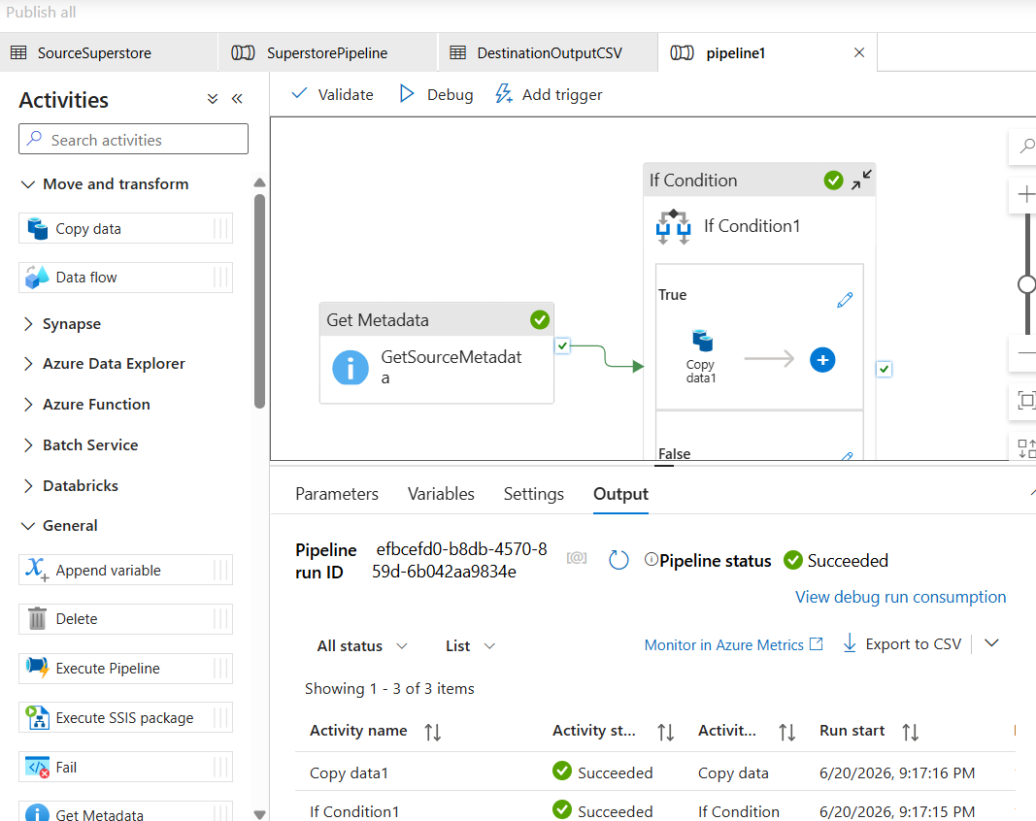

Data copied to destination

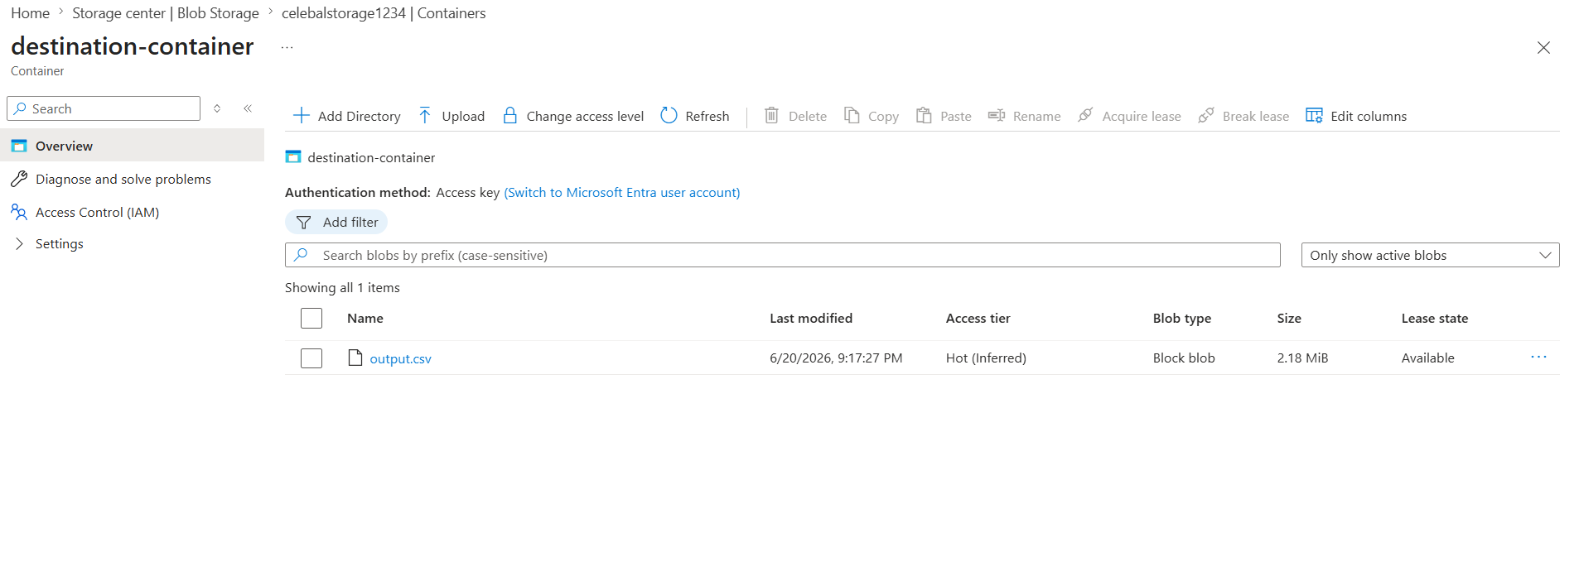

Metadata validated

